The Circle
- There are 2 types of circle on the course:

$$x^{2}+y^{2}=r^{2}$$

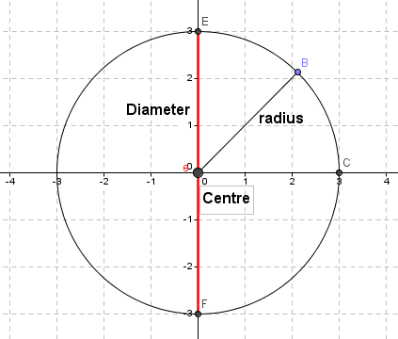
The centre of any circle in this form is always $(0,0)$ and the radius is always $r$.
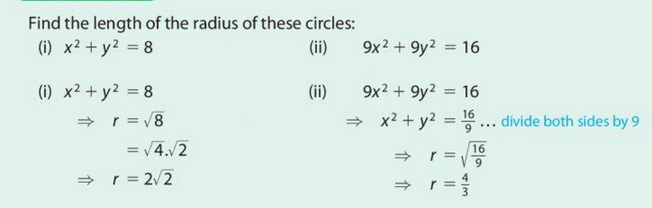
          - the centre of the circle is $(0, 0)$ and $r=2\sqrt{2}$
          - the centre of the circle is $(0, 0)$ and $r= \frac{4}{3}$

$${\left( x-h\right)}^{2}+{\left(y-k\right)}^{2}=r^{2}$$
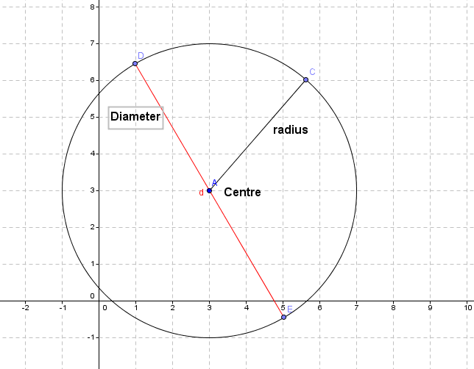
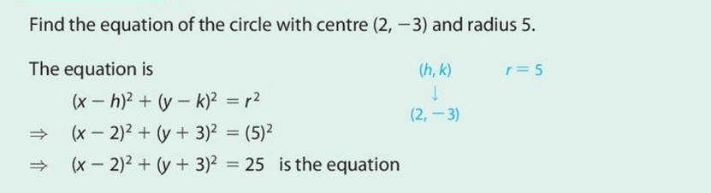
- the centre is (h,k) so you have to decide what value you put in for h and k that may change it from a negative to a positive or leave it as a positive.
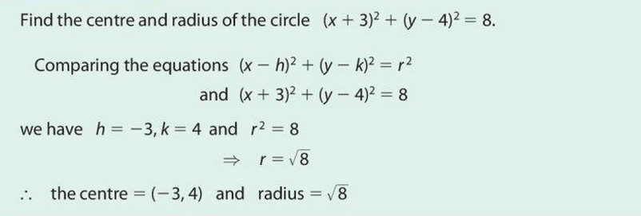
Checking if a point is ON,INSIDE or OUTSIDE a circle
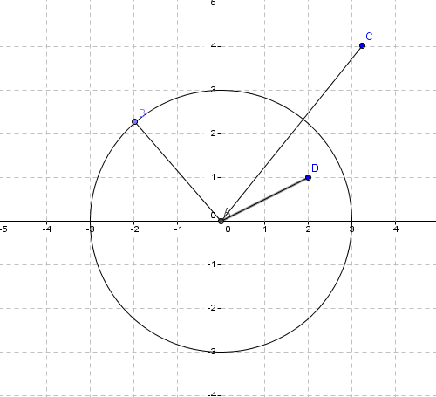
Above there is a circle with a centre (0, 0) and a radius = 3units
We can see that the point B is on the circle
We can see that the point C is outside the circle
We can see that the point D is inside the circle
- we could use the distance formula between the 2 points and if your answer is :
  - Answer › radius tells us the point is OUTSIDE
  - Answer ‹ radius tells us the point is INSIDE
  - Answer = radius tells us the point is ON
OR
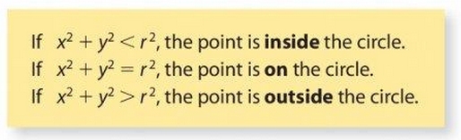
Showing the point/s of intersection between line and circle
NB: you will be given the equation of a line and a circle
- Step 1: manipulate the LINE and rearrange it where you have either $x=…$ or $y=…$
- Step 2: take your expression from Step 1 ($x=…$ or $y=…$ )
And sub it in to the equation of the circle and SOLVE
- Step 3: when you have the solutions from Step 2 you sub them back in to Step 1 to find the corresponding values
- THESE ARE YOUR COORDINATES OF WHERE THE CIRCLE AND LINE INTERSECT
- If there are 2 points of contact then the line goes through the circle but if there is only 1 point (repeated) then the line is a tangent line.
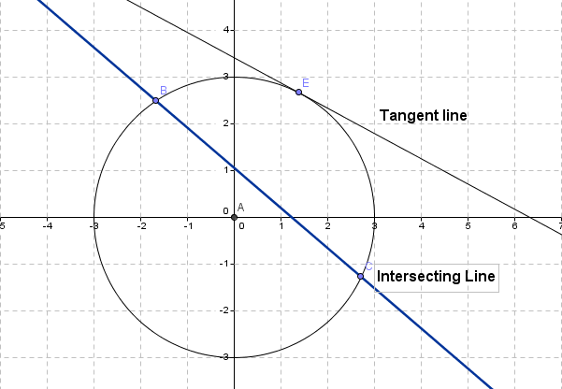

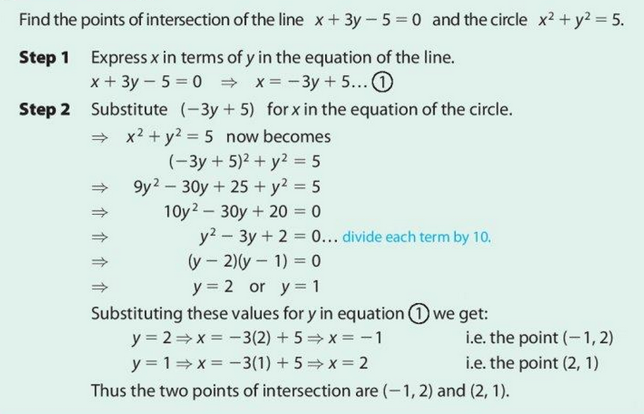
Step 3
In the above example we can see in Step 1 that we have written the line in the form x = …
Step 2 sees the expression for x = … in Step 1 being substituted in to the Circle Equation. Where we have an x is replaced with (-3y + 5)
This equation is now solved - you may of course use the $-b Formula$
We then take the values for $y$ and find corresponding $x-values$
These pairs are the ‘points of contact’ or ‘intersection points’

Finding where circles cross the x and y axis
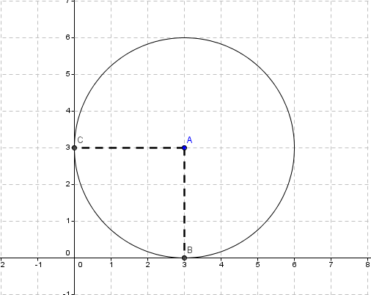
(3, 0)
(0, 3)
- When trying to find where a circle crosses the x – axis put y = 0 in the circle and solve for x
- When trying to find where a circle crosses the y – axis put x = 0 in the circle and solve for y
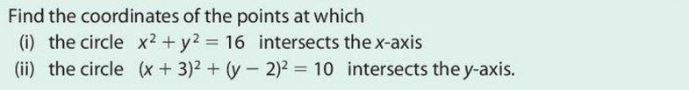
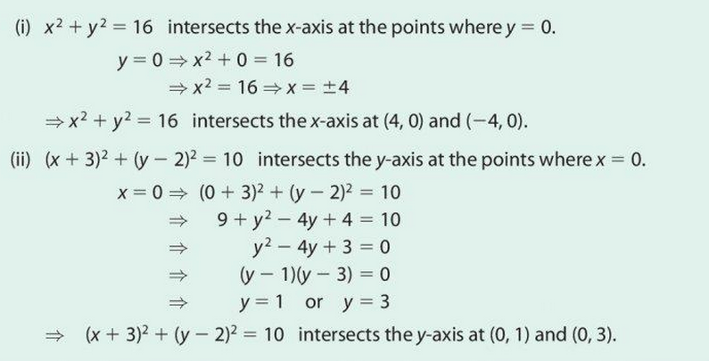
Equation of a Tangent to a Circle at a give point
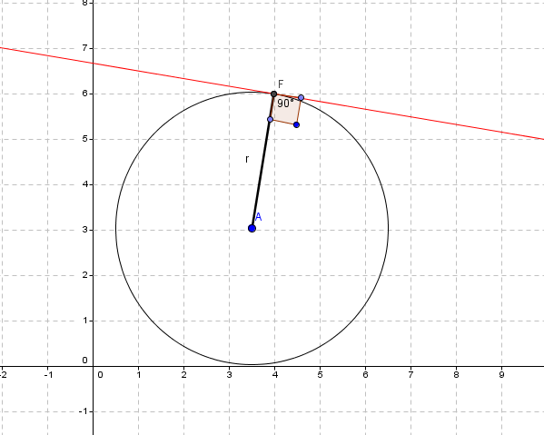
Tangent
- The red line is a tangent line and makes a RIGHT ANGLE with the radius of the circle.
- This means we have to use the Centre and Point of contact and the SLOPE FORMULA to calculate the slope of the radius line segment
- $m_{1} × m_{2}= -1$ :as the radius is at a RIGHT ANGLE to the TANGENT
- When you have found the slope of the TANGENT LINE you can now use this SLOPE and the EQUATION of a LINE Formula to find the Equation of the Tangent Line
$$Slope= \frac{y_{2}- y_{1}}{x_{2}- x_{1}}$$
$$Equation of a line :y- y_{1}=m(x- x_{1})$$
NB : you must have 1. Point & 2. Slope of the tangent before you can get it’s equation.

